CONGRATULATIONS TO THE CLASS OF 2022
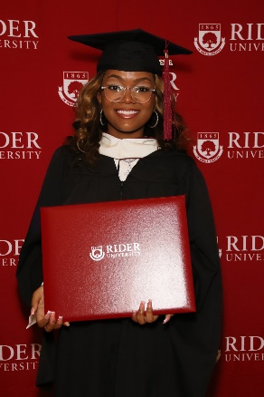  Tatyanna Carman received her Masters degree in Business Communications degree from Rider University. Tatyanna is the Incoming Communications Coordinator at Newark Opportunity Youth Network (NOYN), a non profit organization located in Newark, New Jersey. | 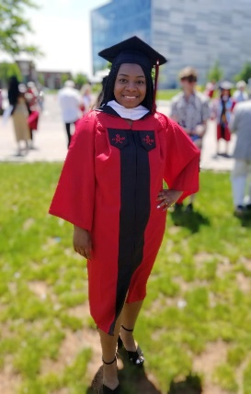  Jamaya Newton received her Bachelor of Arts degree from Rutgers, The State University of New Jersey. Jamaya majored in Communications with a  minor in Dance.  Jamaya is currently working as a Registered Behavioral Therapist, specializing in Autistic children.
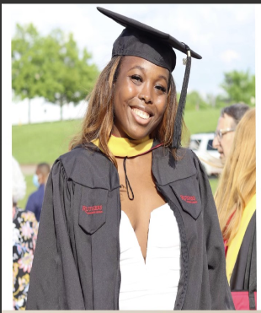  JANAY BORDEAUX received her Masters degree in Social Work from Rutgers University. Janay is a correctional social worker, providing clinical services and community referrals to those who are currently incarcerated. Moreover, she is set to become Licensed Social Worker for the Stat of NJ. | Romelle Watson graduated New Brunswick High School, New Brunswick, NJ. Romelle played football and basketball all four years of high school.  Church activities included: church school, vacation bible school and church services.

